Effective Qualities of Speeches
An effective speech delivers a message that makes sense to the listener and conveys the ideas of the speaker. The “effect” here means having the intended result in the mind of the listener. In other words, if the speaker wants the audience to have a strong emotional reaction and some members weep, the speech was effective. Professional comedians are effective when their audiences laugh. Political speakers get their intended outcome when their audiences applaud and shout encouragement, then go to the polls and vote for that same candidate. And we can measure the effectiveness of our speech when we direct an audience to some immediate and measurable action. However, most of the time, a speaker, such as a preacher or a politician, won’t know whether their words have the intended outcome until some time in the future, if at all.
An effective speech uses variety in language, appropriate gestures and facial expressions, is well-constructed and well-rehearsed, has the needs of the audience clearly outlined, and is consistent with the speaker’s ethos (or credibility). In this class, you will learn how to do research to support your opinions and to arrange those opinions as arguments effectively so that the audience can follow your reasoning and agree with your conclusions. You will also learn how to analyze the needs of the audience, define and limit a topic in order to meet audience needs, then construct and deliver the speech.
The goal of this class is to help you create messages that are clear and organized, that meet specific objectives whether informative or persuasive, and that are designed for comprehension by your audience.

Models
One way to understand the process of communication is to look at a model or drawing that represents the process. No model actually shows real human activity. Humans are too diverse to be described accurately in a simple drawing that assumes only one way of behaving. However, in order to talk about the various elements of human communication, we’ll use a model that helps us understand how the roles of speaker and listener influence the message even if everyone in the class sees themselves as an exception.
Using the most basic elements of the speech process noted above in our discussion of Greek and Roman oratory, we see that the speaker creates a message by putting together words that are organized into a message designed to meet the needs of a specific public audience – a group of listeners.

Speaker Message Audience/Listeners

These three elements are the classical building blocks of public speech. Without a speaker, there is no message. Without an audience, it is not public. Without an organized message, the speech cannot be effective. But other factors influence how the audience receives the message.
According to the model, the audience is not involved in adapting the message while it is being delivered. The speaker prepares the message almost as though the audience won’t be in the room, almost as though it could be phoned in. And the audience members should not expect to influence the message while it is being delivered, although they can convey their reactions non-verbally. This is called a “convention”. This convention assumes that good behavior on the part of classroom audience members means controlling their behaviors and not interrupting the speech no matter how any might feel about the topic or the speaker.
Think what would happen to our model if the audience at a Jay Leno Tonight Show taping were to engage in dialogue with Leno during the monologue? Even though the audience is expected to laugh or groan aloud, their reactions don’t change the actual message that Leno is sharing. If Leno invited a member of the audience to participate in creating his message, we would create a slightly different model showing a conversation between two people, which we call interpersonal communication (inter=between=two). The model would work in both
directions:

Speaker Message Audience/Listeners

While the speaker might have a specific message in mind, the listener can contribute and even change the message. Then the listener becomes the speaker. In real life, these two roles constantly change as conversation overlaps, speaker and listener roles are almost indistinguishable, and the message changes with every transaction. The main point in using this simple model to show the difference between public speaking and conversation is to illustrate that verbal communication seems to go in only one direction – from the speaker to the audience – for public speaking.
However, the audience certainly can impact the speech. And at this point, we would want to look at a more complex model such as the Shannon-Weaver Model1:

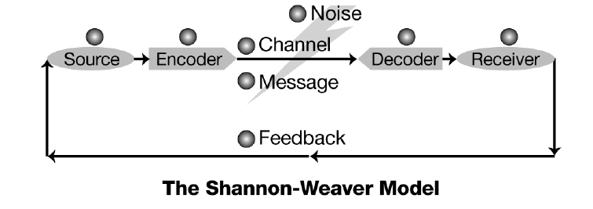

Nonverbal communication such as smiling, frowning, sleeping – all of these actions send feedback to the speaker. Feedback is any audience response to the message which may be intentional or unintentional. Whenever a student looks at their wristwatch during a college lecture, the instructor knows that the student is more focused on how much longer the class will last than on the lecture material. While this might be a natural reaction to a late-running class just before lunch, it may have unintended repercussions on the audience member. Remember – the speaker can see you! Audience members who sleep or fidget or whisper to one another are “telling” the speaker that they don’t care about the message, even if that is not what they intend to do. Occasionally, it might be necessary for a listener to signal a speaker. If the speaker’s voice is very light or the room is large, listeners at the back of the audience may not be able to hear the message. An audience member who cups an ear with their hand to indicate their inability to hear may help the speaker deliver a better message by speaking more loudly. However, an audience member who shouts out, “I can’t hear you!” may be correctly describing the situation, but they have taken away the speaker’s role and diminished the speaker’s credibility.
So, it is very important to understand that the roles of speaker and listener are interdependent but separate. A speaker relies on the listeners to engage in the presentation, to behave in a respectful manner, and to be aware of their nonverbal signals so that the speaker is assisted in presenting the best possible message. The speaker has a responsibility to analyze the audience and adapt the message to meet the needs of the audience. When both roles are taken seriously, the message becomes more effective for both speakers and listeners.

Note: We communicate all the time, awake or asleep, but the messages we send most of the time are not intended for a large, formal audience or are not organized for deliberate public speaking.

1 Shannon, Claude E. & Warren Weaver (1949): A Mathematical Model of Communication. Urbana, IL:
University of Illinois Press.

