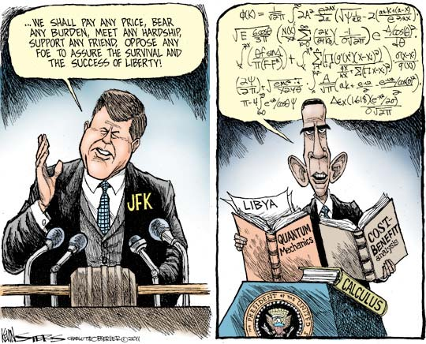

ANALYSIS Questions
- What is the event or issue that inspired the cartoon? Historically or socially, what was happening when this cartoon was made?

- Are there any real people or places in the cartoon? Who are these people? If not, what images are portrayed in the cartoon?

- What words are used? How do the words contribute to the meaning, tone, or effect?

- Identify the specific artistic techniques used in the cartoon (i.e., symbolism, analogy, exaggeration, labeling, and irony). What is the artist trying to show the reader by using these techniques?

- What is the cartoonist's point of view about the topic portrayed in the cartoon? Give examples to support your interpretation.

- Is this cartoon persuasive? Explain why or why not. What other techniques could the artist have used to make this cartoon more persuasive?

- Does the cartoonist use satire in his drawings? Explain why or why not.

