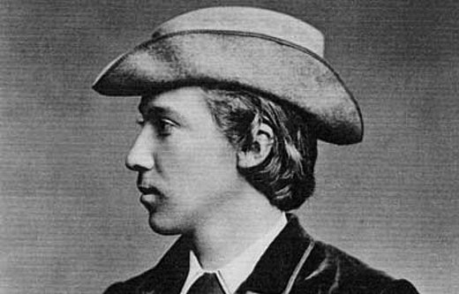
While in England in April of 1866, the future author of Treasure Island, Robert Louis Stevenson, wrote the following letter to his father in Scotland and expertly asked for some money. He was just 15 years of age at the time.
(Source: The Letters of Robert Louis Stevenson, Vol. I (1868-1880); Image: Robert Louis Stevenson, aged 15, via EdinPhoto.)
2 SULYARDE TERRACE, TORQUAY
Thursday
Respected Paternal Relative:
I write to make a request of the most moderate nature. Every year I have cost you an enormous—nay, elephantine—sum of money for drugs and physician's fees, and the most expensive time of the twelve months was March.
But this year the biting Oriental blasts, the howling tempests, and the general ailments of the human race have been successfully braved by yours truly.
Does not this deserve remuneration?
I appeal to your charity, I appeal to your generosity, I appeal to your justice, I appeal to your accounts, I appeal, in fine, to your purse.
My sense of generosity forbids the receipt of more—my sense of justice forbids the receipt of less—than half a crown.
Greeting from, Sir, your most affectionate and needy son,
R. STEVENSON.

