Satire Is as American as Apple Pie by MATTHEW SWAYNE Jan. 30, 2015, at 7:00 p.m This post first appeared at www.futurity.org, which features the latest discoveries by scientists at top research universities in the U.S., U.K., Canada, Europe, Asia, and Australia. Matthew Swayne is a writer at Penn State University.

Why we need satire when times are tough.
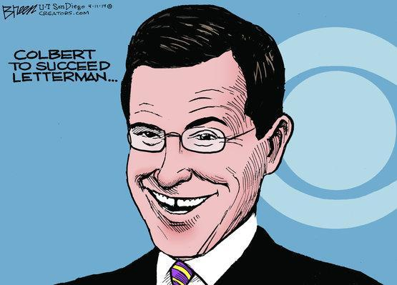
The satire and comedy of Stephen Colbert continues a long tradition in America, and is needed in a free republic, according to a new report.
I already knew that I was going to miss the Colbert Report, and its wry, satirical take on politics and culture. Now, a fascinating new book that traces the use of satire as a form of political engagement from the days of the American Revolution to today’s turbulent political era shows us why it just may save us during tough times – and why all of us will suffer the loss of Stephen Colbert’s jabs each night.
Mark Twain showed us that great writing lends itself to equally compelling satire. Ben Franklin used satire to build popular resentment against the tyranny of kings. Satire gives us a chance to confront difficult subjects in tough times. It’s like a relief valve during turbulent political times. And, quite often, satirists are the only ones willing to take on taboo subjects – something we can all agree is necessary.
Jeff Nesbit
Satire isn’t just entertainment, according to the authors of a new book. It’s a vital function of democratic society and a way to broach taboo subjects, especially in times of crisis.
“Robust satire is often a sign of crisis and the ability to share and consume it is a sign of a free society,” says Sophia McClennen, professor of international affairs and comparative literature and director of Penn State’s Center for Global Studies.
“We see satire emerge when political discourse is in crisis and when it becomes important to use satirical comedy to put political pressure on misinformation, folly, and the abuse of power.”
McClennen and Remy Maisel, a recent Penn State undergraduate in media studies, trace the use of satire as an American form of political engagement from the country’s colonial era to the present high-tech, multimedia satire in Is Satire Saving Our Nation? (Palgrave 2014).
Satirical cartoons—especially ones that painted King George as a buffoon—flourished in America before and during the Revolutionary War. Benjamin Franklin and Mark Twain, two of America’s favorite writers, were also both excellent satirists.
“The Founders didn’t just enjoy humor—they believed it was politically important,” the authors write. “And so they employed the pen and the sword, using satirical works as ‘weapons in a literary and ideological war to decide the future of the new Republic.'”
Shortly after the 9/11 terrorist attacks, television satirists, such as Jon Stewart, who hosts the Daily Show, and Stephen Colbert, who hosted the Colbert Report, were among the few critical voices speaking out about the U.S. government and its policies, according to the researchers.
While satire has always been part of the nation’s political landscape, technology is changing who creates satire and how it is accessed, according to the researchers.
Unlike Franklin and Twain, current satirists are not necessarily professional writers or journalists. Satirists increasingly belong to a generation of Americans born from the early 1980s to early 2000s—often referred to as millennials—and are using social media like Twitter to spread satire.
In another major change, millennials are relying on Stewart, Colbert, and other television satirists, not just for a source of amusement, but as sources of news and information.
There are also differences in the ways comedians approach satire on television, says Maisel.
“Stewart generally breaks down the news from the mainstream media, but Colbert not only breaks the news down, he also gets to add parody as an extra satirical layer because he is coming at the material in the character of a right wing pundit,” says Maisel.
Many citizens do not “get” satire, or its larger purpose, and criticize it for being, at best, entertainment, and, at worst, mockery and ridicule, according to the researchers. The goal of good satire is not mockery, but to generate debate and conversation about subjects.
“The point is this—and it has to be emphasized again and again—satire only reminds us of the sad state of affairs; it doesn’t create it, it can’t mock what doesn’t exist,” the authors write.
“But, as we’ve explained, satire’s goal is not demoralizing mockery; its goal is to invigorate public debate, encourage critical thinking, and call on citizens to question the status quo.”
Maisel, who graduated from Penn State in fall 2014, began collaborating with McClennen as an undergraduate student when the two discovered they were both blogging about satire.
“Remy didn’t just help me write the book, this was a real collaboration,” McClennen says. ” I wanted a millennial to work on this and, in our case, Remy brought her own originality and creative ideas, which led to a diversity of experience and ways of thinking about the research.”

