Vanity Fair

February 2011

From That Day Forth
Washington had never seen anything like it: the tidal wave of glamour, promise, and high spirits that descended on the capital for the 1961 inauguration of the youngest president ever elected, John F. Kennedy—a movable, star-studded bash that couldn't be stopped even by a massive snowstorm. From Frank Sinatra's gala and Jacqueline Kennedy's eclectic V.I.P. list to J.F.K.'s late-night revels, the author collects the memories of those who, 50 years on, are still reliving that glorious dawn.
Related: The Vanity Fair Kennedys Archive.
By Todd S. Purdum
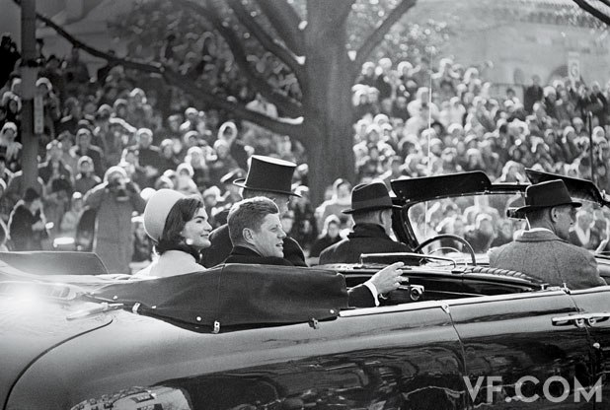“A NEW GENERATION”
First Lady Jacqueline Kennedy and President John Fitzgerald Kennedy make their way down Pennsylvania Avenue after Kennedy’s swearing-in, January 20, 1961. A winter storm had blanketed Washington the day before, but workers with shovels and flamethrowers, displaying “Ask not” spirit, made the capital ready by morning. From CPI/The Phil Stern Gallery.

On Wednesday morning, January 18, 1961, the restless, chestnut-haired 43-year-old man who was preparing, as he would soon put it, to defend freedom in its hour of maximum danger as the next president of the United States was feeling fat. From his family’s duplex penthouse at the Carlyle Hotel, in Manhattan, John Fitzgerald Kennedy had a telephone conference with his internist, who suggested that any extra pounds were the result of trading the frantic pace and infrequent meals of a presidential campaign for the more relaxing transition, and would soon burn away. Reassured, Kennedy ordered his usual high-cholesterol breakfast of broiled bacon, soft-boiled eggs, orange juice, buttered toast with marmalade, and coffee with cream and sugar.
Later that day, he reviewed a selection of silk top hats and underwent a final fitting of the cutaway coat, gray vest, and striped trousers he would wear at his inauguration—a fitting necessitated by the recent weight gain—and still later he had his mouthful of prominent teeth cleaned and polished to their brightest white, the better to stand out against the dark tan he had acquired at his family’s home in Palm Beach in the preceding weeks. Then he hopped a late-afternoon commercial flight from La Guardia Airport to Washington, D.C., and his date with destiny. It seems unlikely that he ever saw the plaintive telegram that arrived for him at the Carlyle that day from one Douglas Temple, of Huntington Station, Long Island: spent money for formal clothes and trip for ceremony. now told only souvenir invitation. please help.
Please help, indeed. As Douglas Temple doubtless knew, Washington was bracing for what became perhaps the biggest and best political party of the 20th century—a “gilt-edged, mink-lined, silk-hatted, 10-gallon, 100-proof” celebration, as a greenhorn Washington Post reporter named Tom Wolfe summed it up at the time. Everyone who was anyone in Democratic politics was there, or wanted to be. The president-elect and his elegant wife, Jacqueline, had made a special point of inviting not only the usual hacks and flacks but also a select group of scholars, artists, writers, and thinkers, from Carl Sandburg and John Steinbeck to Ernest Hemingway and Mark Rothko. (Jackie had also taken pains to invite Mr. and Mrs. T. Reed Vreeland, of 550 Park Avenue—Diana Vreeland was the soon-to-be editor of Vogue and the empress of American taste—and to ask that they get “the most VIP treatment” of anyone on her list.)
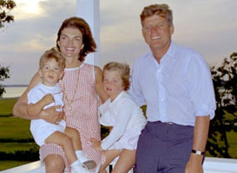
The Vanity Fair Kennedys Archive

Frank Sinatra, who had pioneered celebrity political endorsements by working for F.D.R., and who had campaigned tirelessly for J.F.K., enlisted two planeloads of first-rank entertainers to perform at the inaugural-eve gala, an ensemble that the columnist Murray Kempton described as “the most inescapably valuable collection of flesh this side of the register of maharani.” The troupe had already been royally entertained on the evening of the 17th at a dinner dance at the Georgetown home of the president-elect’s sister and brother-in-law Jean and Stephen Smith. Kennedy himself had stopped by the Smiths’ party before heading up to New York for his last-minute buffing (and, as the writer Thurston Clarke later revealed in his book Ask Not, one last pre-presidential rendezvous with the wife of a nato diplomat who had flown in from Paris for the occasion). Now he was back in Washington, the youngest person ever elected to the presidency, ready to succeed Dwight D. Eisenhower, who was then the oldest man ever to hold it, and who had been the Supreme Commander of Allied Forces in Europe when Kennedy was a navy lieutenant junior grade on PT 109 in the Pacific.
Fifty years on, the sheer glamour of Kennedy’s inauguration, the sense of possibility and promise in the winter air, and the striking, even shocking youth of the principal players still shine bright in the country’s collective consciousness, in the yellowing letters and telegrams at the Kennedy Library, and in the memories of the dwindling band of people who were there. “It was really a generation-changing event,” remembers Newt Minow, the young Chicago lawyer who came to Washington on the train with his wife, Jo, and their friends Sargent and Eunice Shriver, Kennedy’s brother-in-law and sister, ready to assume the chairmanship of the Federal Communications Commission (and ready, too, barely four months later, to pronounce television programming “a vast wasteland”). Already a veteran of Adlai Stevenson’s two presidential campaigns and a Supreme Court clerkship, Minow was the very model of a New Frontiersman. When he told Stevenson, who had been painfully passed over for secretary of state, what Kennedy had in mind for himself, Minow recalls, “Adlai said, ‘Oh, you must have misunderstood. You’re only 34 years old. They’re not going to ask you to be chairman of the F.C.C.’ ” But they had. Decades later, as managing partner of Stevenson’s old Chicago law firm, Minow would, in turn, hire a young summer associate named Barack Obama.
“The environment itself was as charged as any that I’ve ever known,” recalls Harry Belafonte, then not quite 34, whose Calypso had become the first million-selling record album in history, and who had been recruited to join Sinatra’s band of players. “The expectations were so great with Kennedy, and what he represented to us. The expectations were high, and the fact that he’d appointed Sinatra to be in charge of the event even raised our expectations higher, because Frank was no slouch.”
Rosalind Wiener Wyman, just 30, was already a stalwart of the Los Angeles City Council, the youngest member ever elected, and she had made baseball history by helping to bring the Dodgers from Brooklyn to Southern California. In the summer of 1960, she had persuaded Bobby Kennedy to move J.F.K.’s acceptance speech at the Democratic convention from the Los Angeles Sports Arena into the open air of the Memorial Coliseum, and she’d coaxed Sinatra to sing at the first J.F.K. fund-raiser in L.A. after the convention—a midday ladies’ luncheon at the home of Tony Curtis and Janet Leigh that grew from a planned 100 guests to nearly a thousand, requiring Wyman to ask the Curtises’ neighbor (a Republican, no less) to allow the use of his backyard for spillover.
“First, I have to tell Frank that he has to do it twice,” says Wyman, who at 80 remains a fund-raiser and close friend to the likes of Dianne Feinstein and Nancy Pelosi. “Secondly, I said, we have to get you there around 11 because we want you to sing, and then we’re seating them next door for lunch, and then you’re going to reverse. And he said, ‘My God, what kind of stage you got?’ And I said, ‘It really, Frank, only works if you sing off the diving board.’ ” For the inauguration, Wyman and her husband, Gene, were in Washington, helping Sinatra with arrangements for the gala, no easy task given the egos involved and the dank and drafty auditorium: the National Guard Armory in a no-man’s-land neighborhood east of the Capitol building. Sinatra had brought along Phil Stern, one of the top Hollywood photographers of the day, and given him unusual backstage access to rehearsals. (Some of Stern’s images would wind up in Life magazine.)
“The way they rehearsed that foolishness!” recalls Richard Donahue, now 83, a Kennedy-campaign hand who was helping organize patronage appointments for the new administration and was headed for a job in the White House. “They were in a hotel, the Statler-Hilton, and they were upstairs, where there were jars and jars of liquor in all kinds of places. And I don’t think they started to rehearse until one o’clock in the morning. And they were all, being the stars that they were, somewhat, you know, tender about how things worked.”
The one sour note as the rehearsals proceeded was the forced absence of Sinatra’s good pal Sammy Davis Jr., who had been banned from the proceedings on the orders of Ambassador Joseph P. Kennedy because of Davis’s recent marriage to the white Swedish actress May Britt. “It was one of those moments,” Belafonte recalls, “where not only was Frank not happy about it, the rest of us were put up against a moment where [we thought], How do we let this slide? And since we were not really and truly in command of what the total facts were, because the fact that it was the ambassador … we didn’t know that until after. And Sammy not being there was a loss.”

